Frame of reference
It is now October 15, 2020. You've just completed the work to create the list of tasks at the end of Part 1. You need to update your boss to make sure that you've got a reasonable understanding of the breakdown of work, provide a potential time frame to complete, plus any other info you think important. ﻿﻿﻿﻿﻿﻿﻿ Be careful how you express the software's calculated end date since you don't have resources loaded yet so the end date may not be final. End with some words on your next steps.

Consider the Project Priority Matrix on page 616. Although your boss’ first concern is cost, you must have an agreement on the deliverables and work involved before you can finalize cost and timing. From what you know now, the question to really ask is “is the end date reasonable/acceptable” since that’s all you have at this point.

Procedure
- Complete steps 1 – 5 as described in the text book, page 617, Part 1
- Step 6: change the start date to January 4, 2021
- Create a 2-page Word document
  - page 1: updated project preliminary scope
  - page 2: picture of both Gantt Chart and Network Diagram
    - must use the "copy picture" function within MS Project
    - follow instructions in this document’s appendix
- Step 7: Write an email (not a memo) containing
  - Responses to question 7, parts a, c, d, and e.
  - Discuss what you think your boss is most interested in based on the information requested and the project priority matrix in the project introduction. Make sure your communication has a sense of purpose.
- Send the email with the Word document attached to angoliam@ecu.edu
- Upload the MS Project file to the Bb assignment (only)

Assignment Deliverables
- An email sent to angoliam@ecu.edu
- 2 files submitted to Bb: Word document and MSP file
Technical Requirements
- The email must be in sentence and paragraph format; all prior formatting rules apply
- Beyond answering the Q7 parts, you must provide a sense of purpose in sending me an email
- For Q7d, include "why" (or not) you consider the network sensitive and why you care
- MSP file
  - All tasks must be revised from the text book Part 1 WBS into "verb-noun" format
  - Top line in the project shows POM+ and your last name
  - WBS Outline numbers
  - date format mm/dd/yy (without the day of the week)
  - durations and date columns right justified; predecessors centered
- The Word document in portrait orientation with a page header of document title, your name, date
- Name all files: yourlastname-POM 1 (one will be .docx and the other .mpp)
Limits and Exclusions
- The email may not be a list of bullet statements answering the questions
- Do not answer Q7.b; for Q7e, do not use the term "sensible" in your answer
- Do not use activity numbers in the email
- Do not use any information from the text beyond POM 1
Appendix: Instructions to Create Gantt Chart and Network Diagram Views
At the bottom of Page 1, go to the PAGE LAYOUT ribbon, then Breaks > Next Page to modify margins and/or orientation for more space. The Gantt chart needs to be readable.

Gantt Chart: Table > Entry
Show only the tasks, start, finish, duration, and bars by sliding the vertical bar left.
Do not show the predecessors – the Gantt bars do that graphically.
From the Gantt chart view, click “copy picture” and set the following parameters (note the dates). After copying into Word, you may need to stretch the picture vertically to make the Task Names visible; you may adjust margins and/or page orientation.
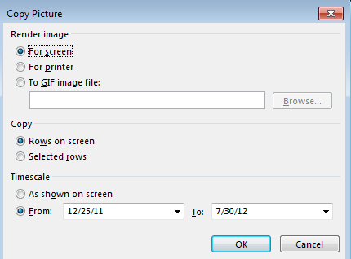
Keep the month and day but adjust the year per the project file

MSP Network Diagram view settings (right click from within the Network Diagram view and select “layout”); make sure to check the box to Hide all fields except ID. Use “copy picture” or snipping tool to create a copy. After pasting into Word, go to Format > Picture Border to draw a border around the diagram. Expand picture to show full width of page.

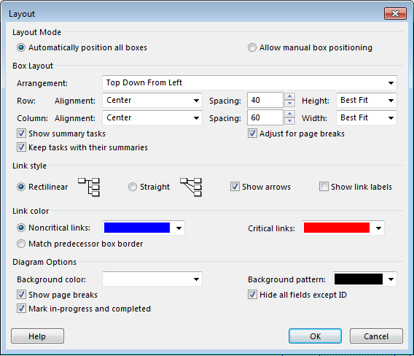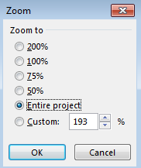

Gantt Chart
Sample only: your dates will be different per your start date; picture is vertically stretched as shown below)
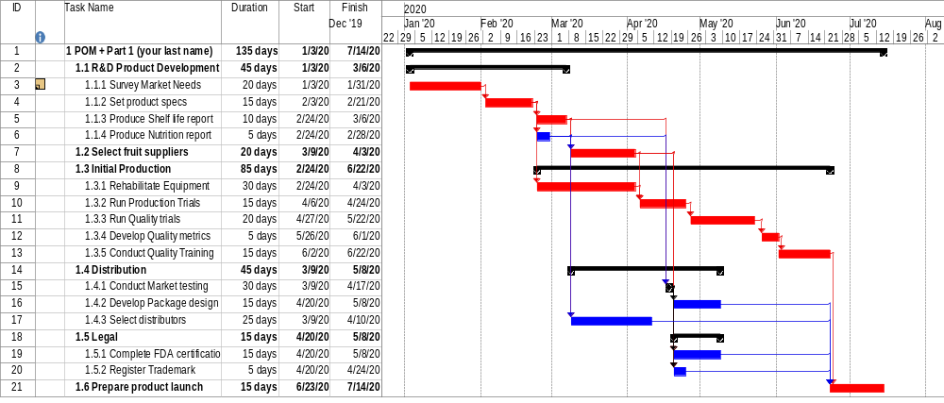

Network Diagram
